MIDTERM REVIEW WORKBOOK

Automotive Electrical
Concepts, circuits, meter skills, diagnostics, and electrical calculations
NAME  ________________________ | CLASS / PERIOD  ________________ | DATE  ____________
YOUR REVIEW ROUTE
01  FOUNDATIONS | 02  CIRCUITS | 03  MULTIMETER | 04  DIAGNOSTICS + LAWS
HOW TO USE THIS PACKET
- Complete each section from memory first. Use pencil and show every step.
- Check your work with notes or a classmate in a different color.
- Star any item you cannot explain aloud without looking at your notes.
- Bring those starred items to the review session and ask a specific question.
READY MEANS: I can select the correct formula or meter setup, label units, trace the circuit, and explain why the result makes sense.
COMPLETE | CHECK | CORRECT | EXPLAIN

Section 1 | Electrical Theory Review Map
Check each target only when you can define it, give an example, and explain why it matters in a circuit.

1.1 What is Electricity?

Energy
  - Define Energy
  - Types
  - Law of Conservation

Matter and Atoms
  - Define matter, molecules, and atoms
  - Use the periodic table to identify atomic information
  - Atomic Structure
  - Explain the roles of protons, neutrons, and electrons

Ions
  - Define ions
  - Distinguish between positive and negative ions
  - Explain how ions help describe electrical behavior

Conductors vs. Insulators
  - Define conductors and insulators
  - Give examples of conductors and insulators
  - Explain how an insulator can become conductive
  - Describe the basic role of semiconductors

1.2 Electrical Flow

Conventional vs. Electron Flow
  - Define conventional-current and electron-flow theory
  - Explain the origin of each flow theory

AC vs DC
  - Define direct current (DC) and alternating current (AC)
  - Identify where DC is used
  - Identify where AC is used
  - Describe how AC and DC can be converted

Effects of Electrical Flow
  - Identify the effects of electrical current, explain useful applications, and recognize harmful effects.

1.3 Properties of Electricity

Current
  - Define current and state its unit of measurement
  - Explain the effects of high and low current flow
  - Explain its relationship in Ohm’s Law and Watt’s Law

Voltage
  - Define voltage and state its unit of measurement
  - Explain how voltage is generated
  - Explain its relationship in Ohm’s Law and Watt’s Law

Resistance
  - Define Resistance
  - Identify what creates resistance in a circuit
  - Explain its relationship in Ohm’s Law
  - Explain the four factors that affect resistance

Electrical Power
  - Define electrical power and state its unit of measurement
  - Compare electrical power with mechanical power
  - Explain its relationship in Watt’s Law

Energy
Energy is defined by ___________________________________________________________________________________
Types of Energy:
Definitions: | 1-5 | Terms: | A-E | Examples
- Energy stored in chemical bonds.  - Energy from an object's temperature.  - Energy from moving electric charges.  - Energy of motion.  - Stored energy due to position. |  | Kinetic Energy  Potential Energy  Thermal Energy  Chemical Energy  Electrical Energy |  | - A rolling ball  - Water behind a dam  - Boiling water  - Gasoline in a car  - Powering a lamp

The Law of Conservation of Energy is defined as: _______________________________________________________

Matter
_________________________ - Anything that has mass and takes up space.
_________________________ - Two or more atoms bonded together.
_________________________ - The amount of matter in an object.
_________________________ - A chemical bond where atoms share electrons.
_________________________ - A chemical bond where atoms transfer electrons.
_________________________ - The basic building blocks of matter.
- Matter is made of atoms and molecules, bonded by covalent or ionic bonds, and mass measures how much matter they contain.
- Covalent = Cooperate = Share
- Ionic = I Owe = Give or take

Atomic Structure
- _________________________ - Contain 3 particles P_____, N______, and E_______
- _________________________ - Located at the center of an atom and contains Proton and Neutron
- _________________________ - Are positively charged
- _________________________ - Have no charge
- _________________________ - Negatively Charged
- _______________ Rings/Shells - Contains Electrons and can have
- _________________________ - Located in the outer ring/shell
- _________________________ - An extra electron that’s free to float to another

Types of Atoms

- Conductors
- Insulators
- Semiconductors
- Ions
- Positive Ion
- Negative Ion

Electrical Flow

- Conventional Flow
- Electron Flow Theory
- Alternating Current
- Direct Current
- Hole Theory

Properties of Electricity:
- _________________________ - Electrical pressure
- _________________________ - Rate of electron flow
- _________________________ - Opposition to current flow
- _________________________ - Rate at which electrical work is performed
- _________________________ - Unit used to measure voltage
- _________________________ - Unit used to measure current
- _________________________ - Unit used to measure resistance
- _________________________ - Unit used to measure electrical power

_________________________ is electrical pressure that drives _________________________ through _________________________. A load converts that electrical energy into _________________________.

- The greater the difference in electrical charge between two points, the greater the _________________________.
- With resistance held constant, the higher the __________________, the greater the current flow.
- Total circuit __________________ drop equals source voltage.
- Electrical __________________ is consumed by resistance in the circuit.
- In a series circuit, the highest resistance will have the greatest __________________ consumption.

- The intended load should provide the circuit’s primary resistance; unwanted resistance indicates a fault.

Section 2 | Circuit Fundamentals Review Map
Use this map to identify gaps before completing the circuit-analysis activities that follow.

2.1 Circuit Terminology

Definition of a Circuit
  - Explain why a complete circuit must provide a closed path for current.
  - Distinguish among open, closed, and short circuits.

Circuit Symbols and Diagrams
  - Identify common electrical symbols used in schematics.
  - Trace current paths and interpret circuit diagrams.
  - Explain why standardized symbols matter in service information.
  - Practice interpreting circuit diagrams.

Units of Measurement
  - Review SI units used in electrical work: volts, amps, ohms, and watts.
  - Convert among milli-, base-, kilo-, and mega-unit ranges.

Relevant Terms
  - Open vs. Closed (Complete) Circuits
  - Continuity
  - Polarity
  - Ground-Controlled vs. Power-Controlled Circuits

2.2 Five Components of a Circuit

Power Source
  - Define a power source
  - Identify power-source types (AC supply, DC battery, solar cell).
  - Compare primary and secondary power sources
  - Recognize power-source symbols in circuit diagrams.
  - Explain internal resistance in a power source.
  - Recognize battery, generator, and other power-source symbols.

Conductive Path
  - Define a conductive path
  - Materials used as conductors (copper, aluminum, gold, silver).
  - Explain how conductivity affects circuit performance.
  - Explain how conductor length affects resistance
  - Recognize ground, splice, connector, and wire symbols.

Load Device
  - Define a load device
  - Identify resistive, inductive, and capacitive loads.
  - Explain how a load converts electrical energy into heat, light, sound, or motion.
  - Compare steady-current and pulse-controlled loads
  - Explain why the intended load should provide the circuit’s primary resistance.
  - Recognize common load-device symbols

Control Device
  - Define Control Device
  - Identify components used as control devices.
  - Compare common switch types used to control circuits
  - Distinguish power-side control from ground-side control
  - Symbols for the different control devices

Protective Device
  - Define a circuit-protection device
  - Identify fuses, circuit breakers, and fusible links.
  - Explain how protection devices prevent overcurrent damage.
  - Recognize protection-device symbols
  - Apply circuit protection to real-world fault scenarios.

Simple Circuit

Characteristics of a Simple Circuit
  - Define a simple circuit
  - Explain how voltage, current, and resistance interact in a simple circuit.
  - Explain why a closed loop is required for current flow.
  - Predict the effects of opens, shorts, and overloads.

Building and Testing a Simple Circuit
  - Hands-on activity: Constructing a simple circuit using a breadboard.
  - Step-by-step guide on measuring voltage, current, and resistance using a multimeter.
  - Analysis of the impact of different resistances and loads on circuit performance.

Applications of Simple Circuits
  - Real-world examples such as simple lighting circuits, battery-operated devices.
  - Discussion on the importance of simple circuits as the foundation for more complex systems.

Series Circuit

Characteristics of Series Circuits
  - Define a series circuit
  - Voltage
  - Current
  - Resistance

Disadvantages and Advantages
  - Predict circuit operation if one series load opens.
  - Explain how source voltage divides across series loads.
  - Identify one design advantage and one limitation of a series circuit.

Calculating Values in Series Circuits
  - Application of Ohm’s Law to calculate voltage drops, total resistance, and current.
  - Practice problems: Solving for unknown values in series circuits.
  - The importance of understanding power distribution in a series circuit.

Building and Testing a Series Circuit
  - Hands-on activity: Constructing a series circuit with multiple resistors and loads.
  - Measuring voltage drops across each component and comparing with theoretical values.
  - Troubleshooting common issues in series circuits (e.g., identifying failed components).

Applications of Series Circuits
  - Exploration of series circuits in real-world applications like string lights, resistive heating elements.
  - Discussion on the advantages and disadvantages of series circuits in different scenarios.

Parallel Circuit

Characteristics of Parallel Circuits
  - Define a parallel circuit
  - Analysis of how voltage remains constant across all branches in a parallel circuit.
  - Exploration of current division among branches and its dependence on branch resistance.
  - Discussion on the impact of adding or removing components in a parallel circuit.

Advantages and Disadvantages of a Parallel Circuit

Calculating Values in Parallel Circuits
  - Application of Ohm’s Law to calculate total resistance, individual branch currents, and overall current.
  - Practice problems: Solving for unknown values in parallel circuits.
  - The significance of total power calculation in parallel circuits.

Building and Testing a Parallel Circuit
  - Hands-on activity: Constructing a parallel circuit with multiple branches.
  - Measuring voltage and current in each branch and comparing with theoretical predictions.
  - Troubleshooting parallel circuits, identifying open branches or short circuits.

Applications of Parallel Circuits
  - Exploration of parallel circuits in real-world applications like household electrical wiring, automotive electrical systems.
  - Discussion on the advantages of parallel circuits in maintaining functionality even if one branch fails.

Series-Parallel Circuits

Characteristics of Series-Parallel Circuits
  - Define a series-parallel circuit
  - Analysis of how voltage and current are distributed across different sections of the circuit.
  - The interplay between series and parallel elements and their impact on circuit behavior.
  - Discussion on how adding or removing components affects the overall circuit.

Calculating Values in Series-Parallel Circuits
  - Step-by-step approach to solving complex circuits using Ohm’s Law.
  - Techniques for simplifying series-parallel circuits into simpler equivalent circuits.
  - Practice problems: Analyzing and solving for unknown values in series-parallel circuits.

Building and Testing a Series-Parallel Circuit
  - Hands-on activity: Constructing a series-parallel circuit and analyzing its performance.
  - Measuring voltage and current at different points in the circuit and comparing with theoretical calculations.
  - Troubleshooting complex circuits, identifying issues with specific sections.

Applications of Series-Parallel Circuits
  - Exploration of series-parallel circuits in real-world applications such as automotive lighting systems, power distribution networks.
  - Discussion on the advantages of series-parallel circuits in balancing the benefits of both series and parallel configurations

Five Components of a Circuit
1. __________________________ | Supplies electrical energy to the circuit.
2. __________________ Device | Opens the circuit during an overcurrent condition.
3. __________________ Device | Turns the circuit on, off, or otherwise controls operation.
4. __________________________ | Carries current from component to component.
5. __________________________ | Converts electrical energy into another form such as light, heat, sound, or motion.
Effects of Electricity
  - Illumination______________________________

Load Devices | Match the Device to Its Function
1. __________________________ | Converts electrical energy into illumination.
2. __________________________ | Converts electrical energy into heat through resistance.
3. __________________________ | A coil of wire used to create a magnetic field or resistance.
4. __________________________ | Uses electromagnetic force to produce linear motion.
5. __________________________ | Converts an electrical control signal into mechanical movement.
6. __________________________ | Uses electromagnetic force to produce rotational motion.
7. __________________________ | Uses electromagnetic force to open or close another circuit.
8. __________________________ | Converts electrical energy into sound.
9. __________________________ | Transfers energy between circuits through electromagnetic induction and may change voltage.
10. __________________________ | Limits or regulates current flow.

Circuit Terminology
- Open Circuit
- Closed (Complete) Circuit
- Short Circuit
- Continuity
- Energized Circuit
- Polarity
- Reverse Polarity
- Polarity Sensitive
- Forward Bias
- Reverse Bias
  - An LED is installed backward and does not illuminate. Identify the bias condition and explain why current does not flow.
  - A diode has been installed backward. Describe its bias condition and predict the circuit behavior.
  - Before installing a diode, which two polarity checks should be made?
  - A polarized capacitor is connected backward. Predict the failure risk and explain the safety concern.
  - Explain why diode orientation matters to current flow.
- The two sides of a circuit are the __________________ side and the __________________ side.
  - The __________________ side is located between the power source and the load input.
  - The __________________ side is located between the load output and ground.
- Component input is on the __________________ side.
- Component output is on the __________________ side.

Circuit Type:

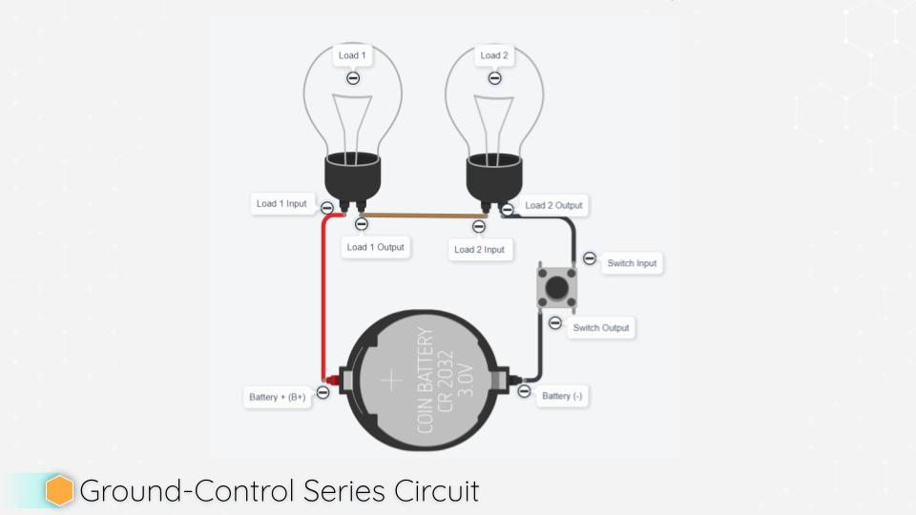 | 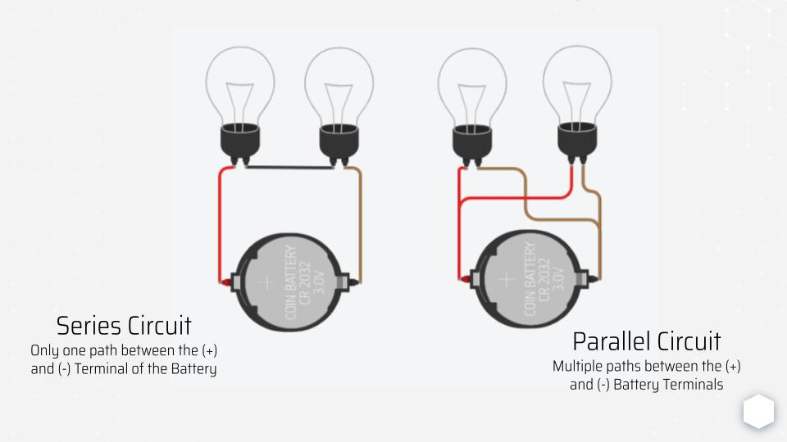
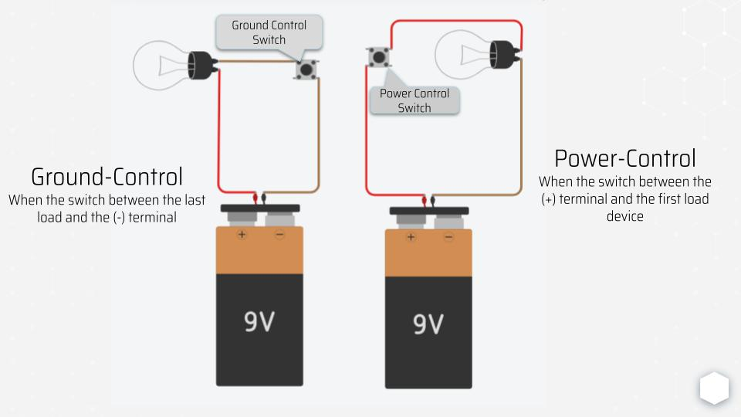 | 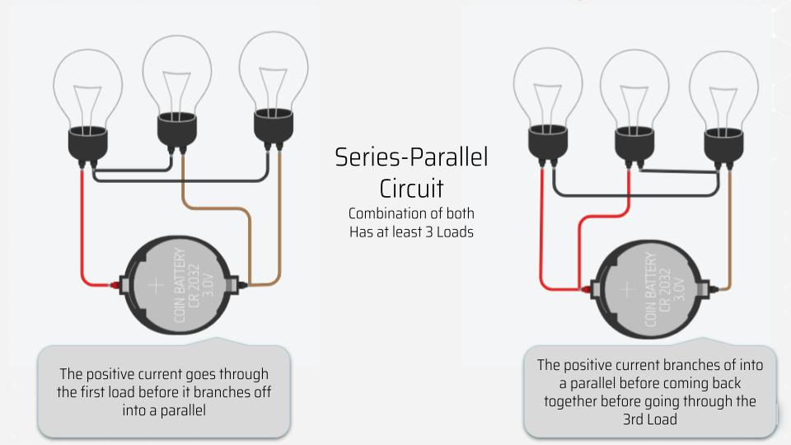

- _________________________ - A circuit with 1 load
- _________________________ - A circuit with at least 2 loads and one path
- _________________________ - A circuit with multiple paths
- _________________________ - A circuit with at least three loads
- _________________________ - A circuit with a switch before loads
- _________________________ - A circuit with the load before the switch
- _________________________ - A circuit with a switch after the loads
- _________________________ - A circuit with the load after the switch

Name the circuit:

- Wire 1: B+ to Switch Input  - Wire 2: Switch Output to Load Input  - Wire 3: Load Output to B- | 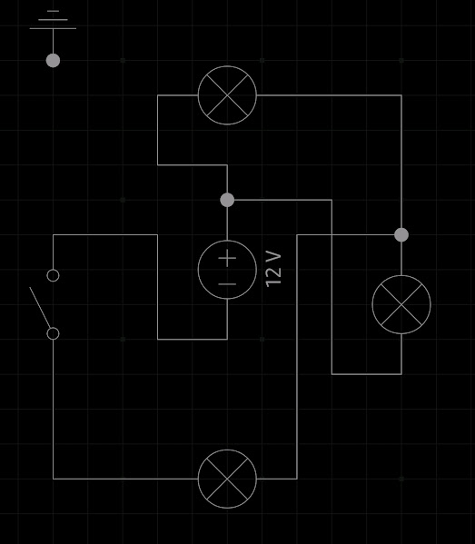 | 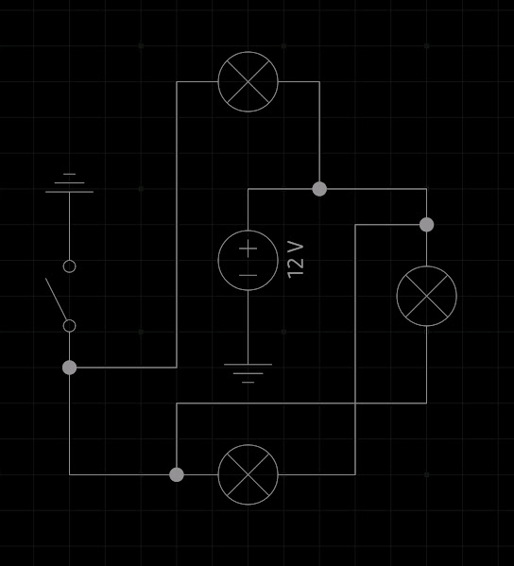
 | 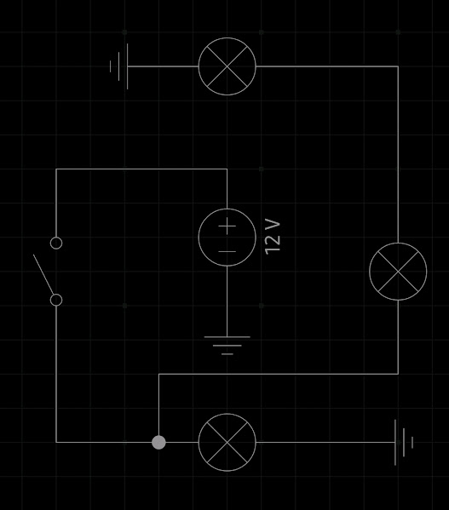
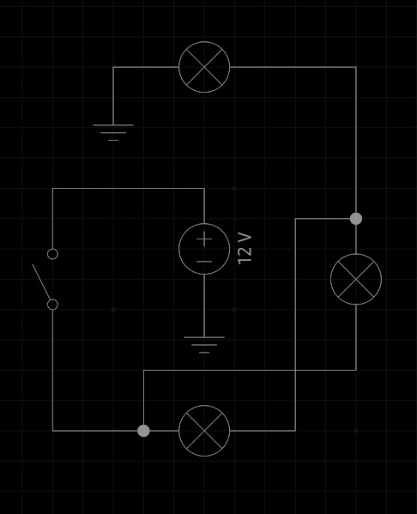 |  | 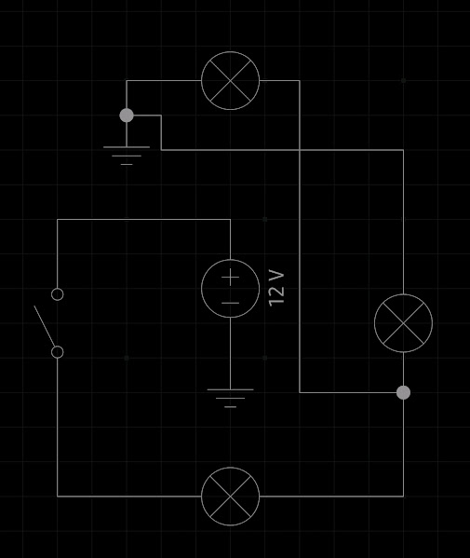
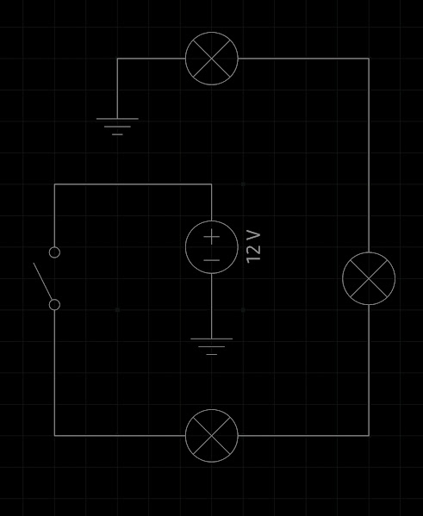 | 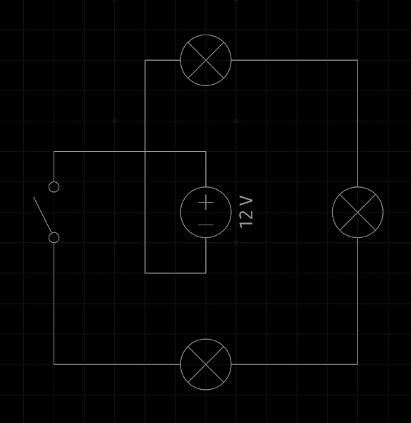 | 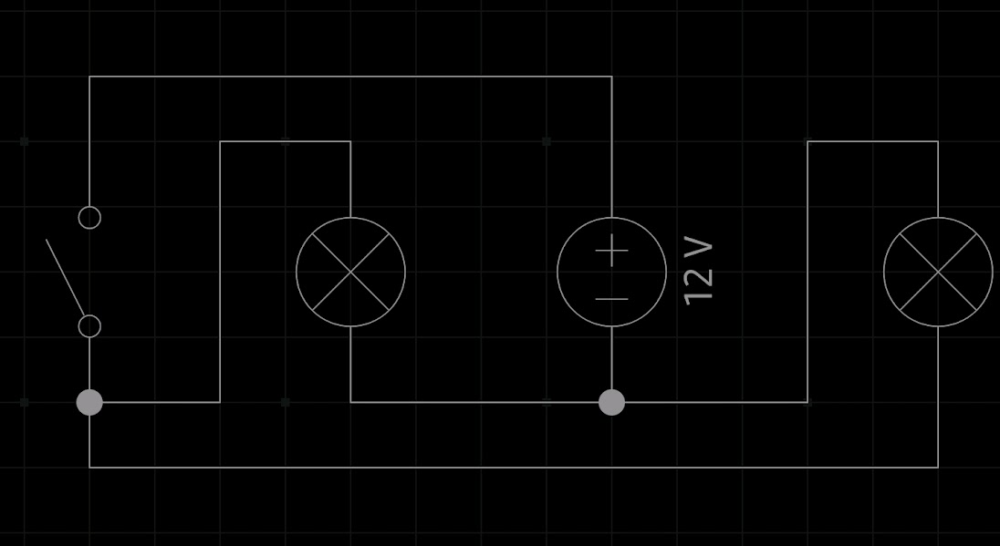

 |  | 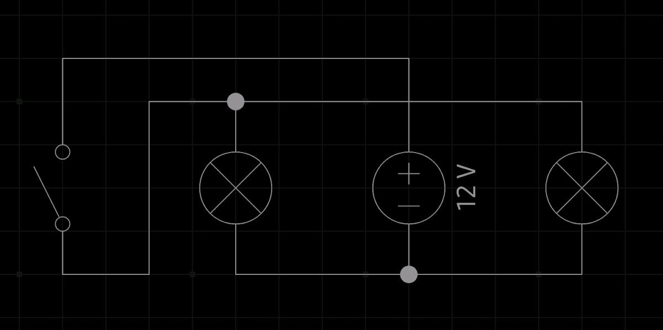
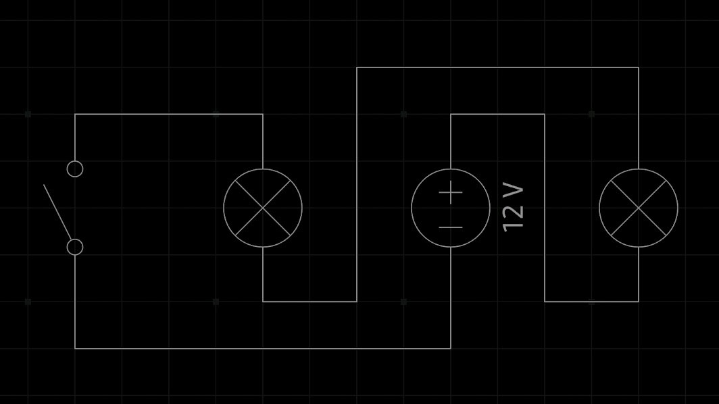 | 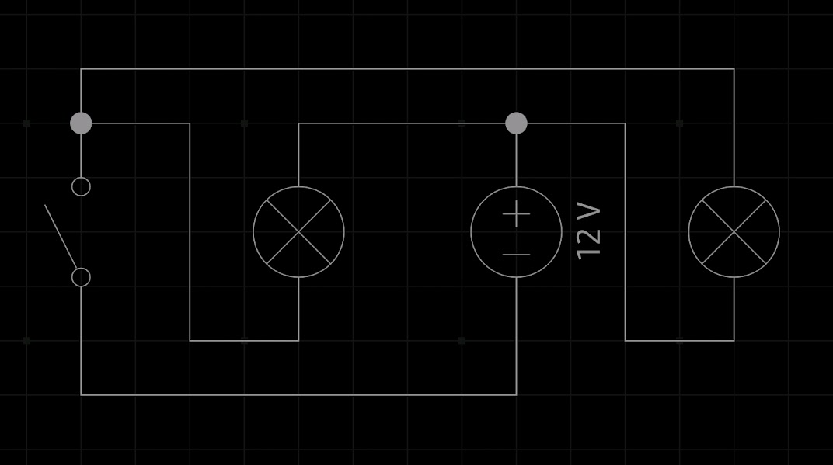 | 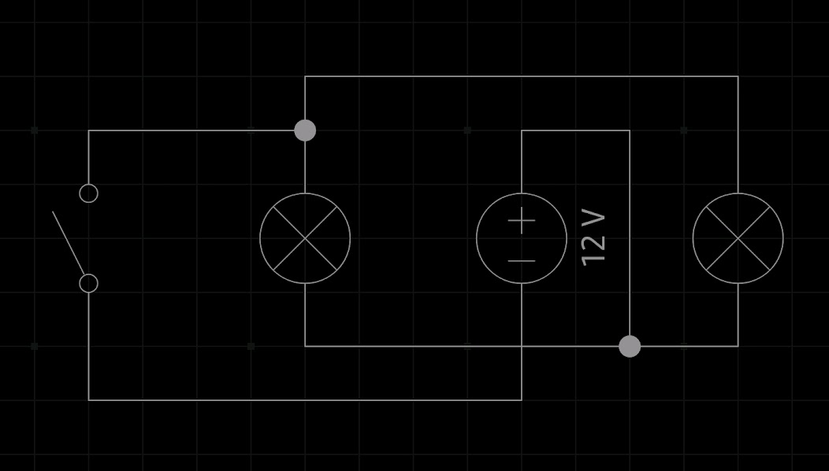 | 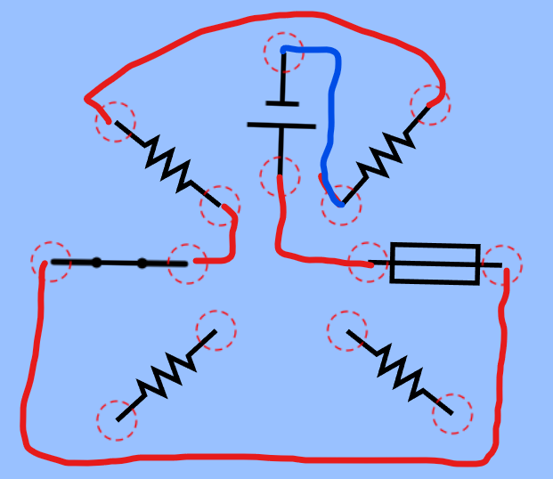
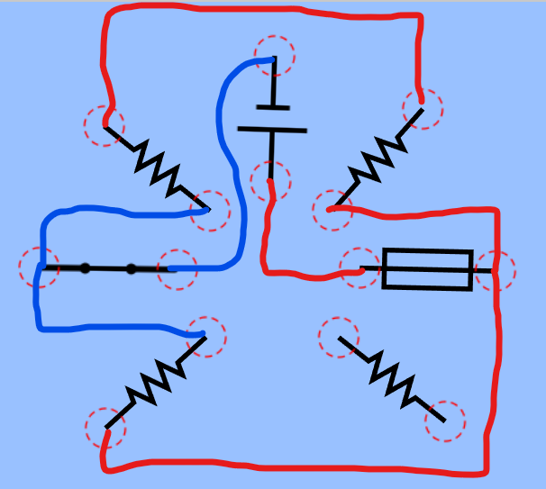

Connect the Circuit
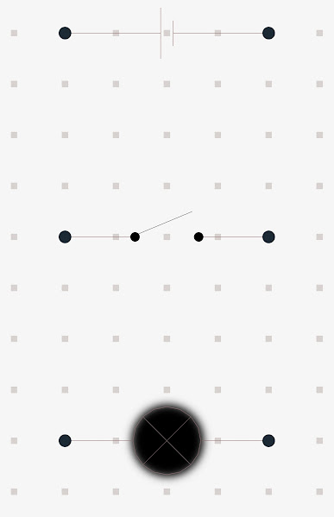
Use all loads to connect create a ground-controlled parallel circuit  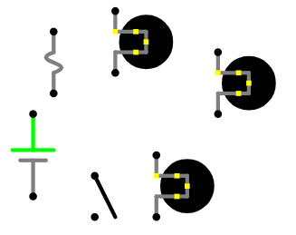 | Connect the dots to create a ground-controlled circuit  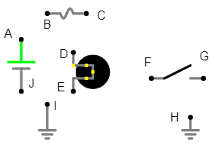
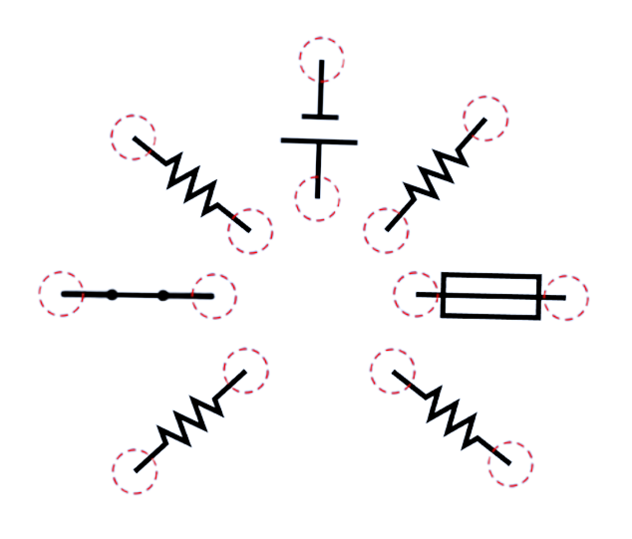

Fill in Components
Add Components Grd Series-Parallel - Falstad  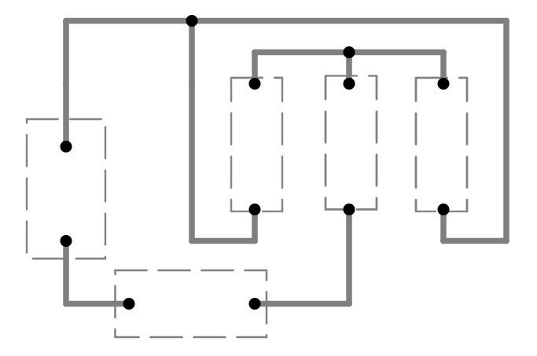 | Add Components - Grd Parallel - Falstad  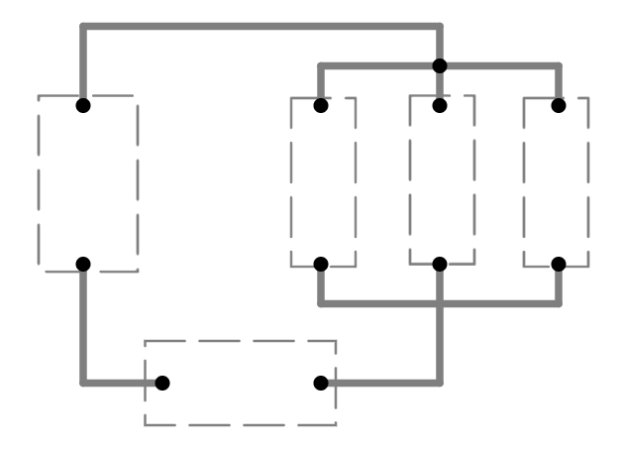
Add Components - Grd Series - Falstad  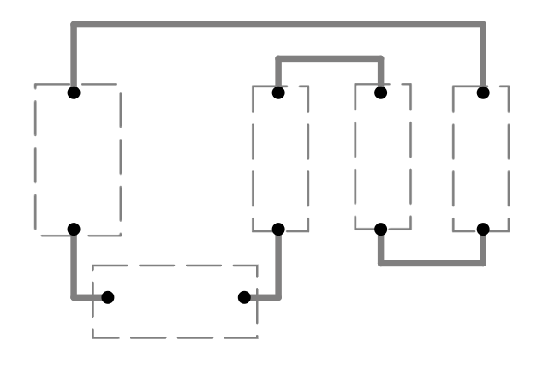 | Add Components - Pow Series-Parallel - Falstad  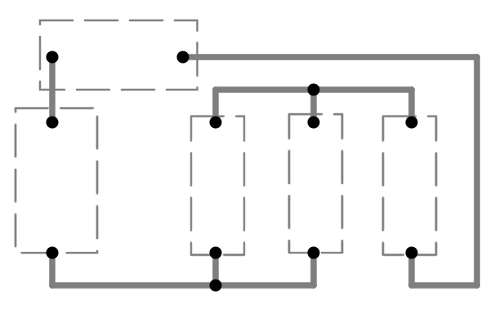

Wire up the Circuit
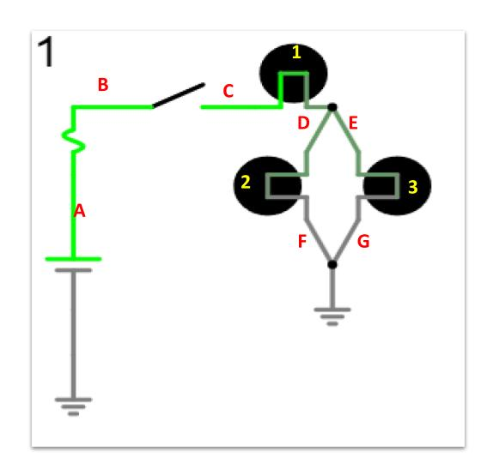 | Wire A. | (B+) | to | Fuse Input
 | Wire B. |  | to
 | Wire C. |  | to
 | Wire D. |  | to
 | Wire E. |  | to
 | Wire F. |  | to
 | Wire G. |  | to

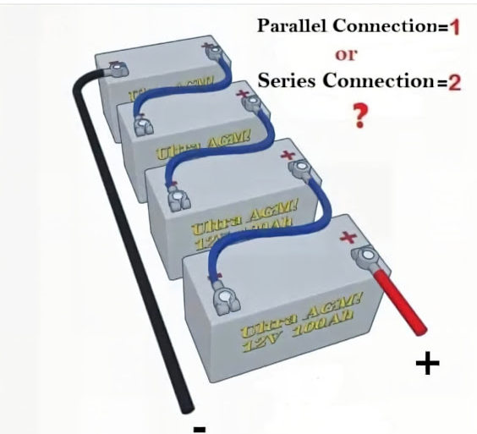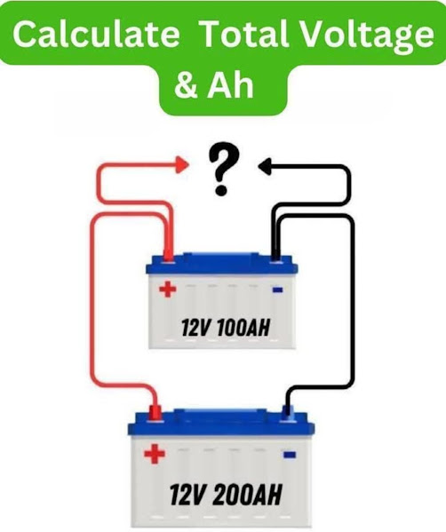
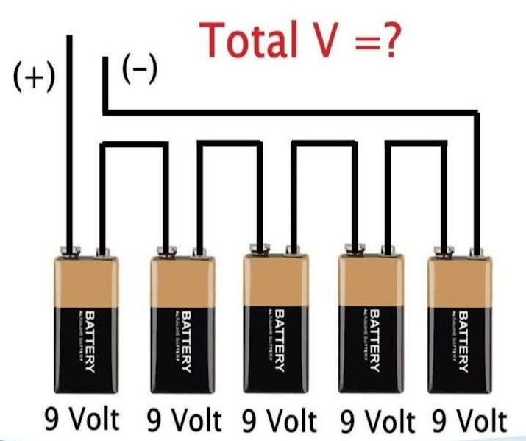
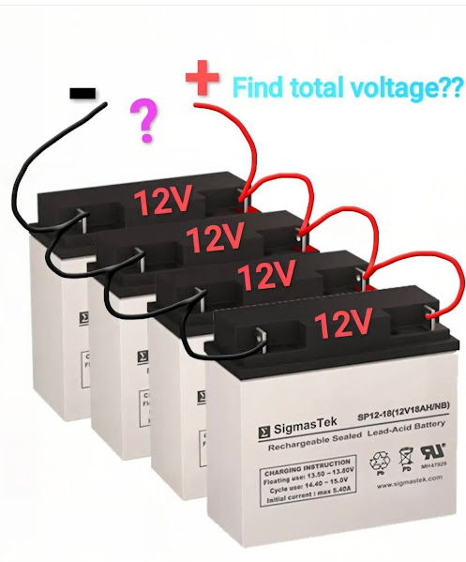

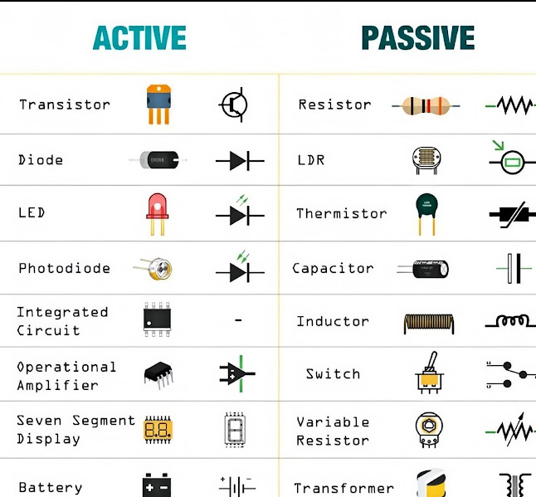

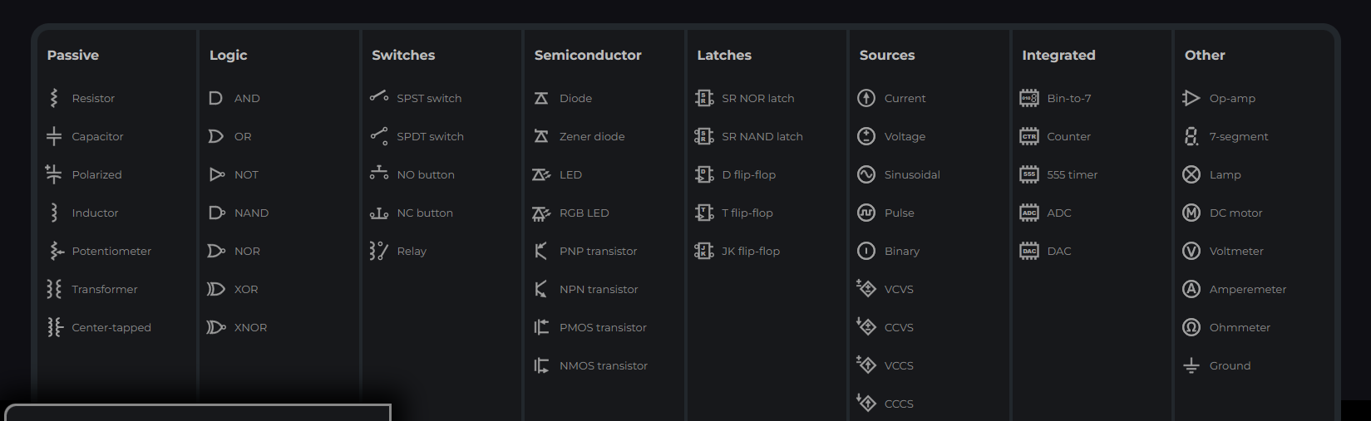

Section 3 | Multimeter Skills
For every measurement, identify the meter mode, lead ports, probe placement, circuit state, and expected reading.

Symbols on a Meter
Alternating Current |  |  | Resistance Testing Symbol
Direct Current |  |  | Diode Testing Symbol
Voltage Testing Symbol |  |  | Continuity Testing Symbol
Amperage Testing Symbol |  |  | Frequency Testing Symbol

Match the Test to the Description
Voltmeter | Measures electrical potential difference and is connected in parallel with the circuit or component.
Ammeter | Measures current and must be connected in series so circuit current flows through the meter.
Ohmmeter | Measures resistance across an isolated component in a de-energized circuit using the meter’s internal source.
Continuity Tester | Checks for a complete low-resistance path and sounds an audible tone when continuity is present.

Multimeter Lead Placement
- Which multimeter port receives the black lead?

- Which multimeter port receives the red lead for voltage and resistance tests?

- Where are the probes placed within the circuit when performing an available voltage test?

- Where are the probes placed within the circuit when performing a voltage drop test?

- Where are the probes placed within the circuit when performing a voltage drop test of the power side?

- Where are the probes placed within the circuit when performing a resistance test?

- How must the meter be connected when performing an amperage test?

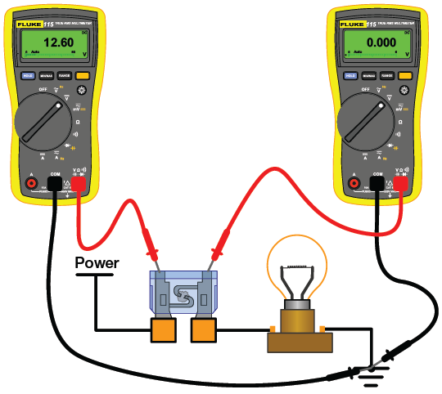 | 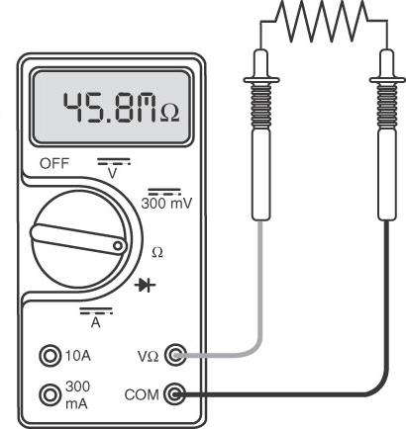
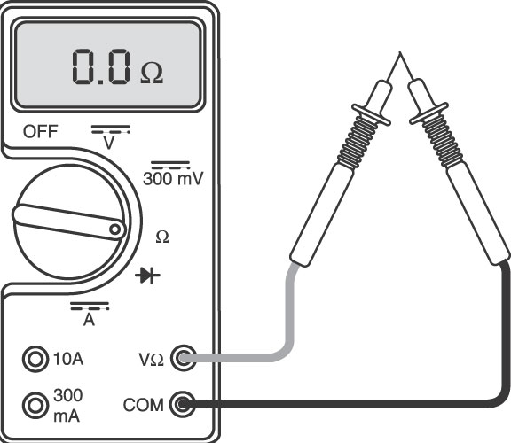 | 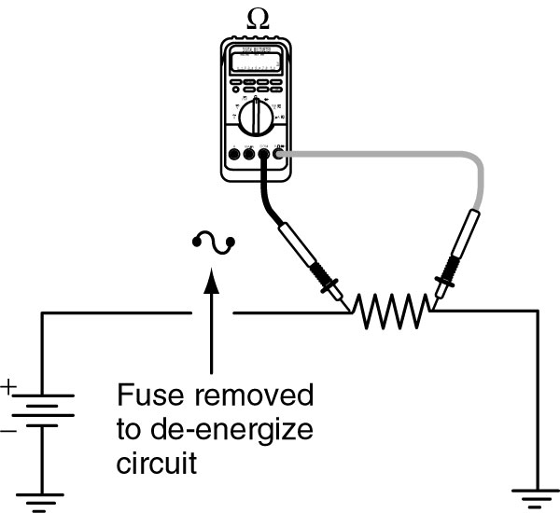
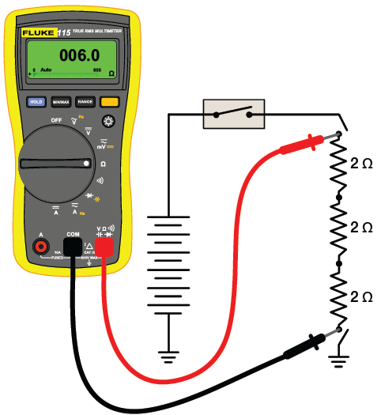 | 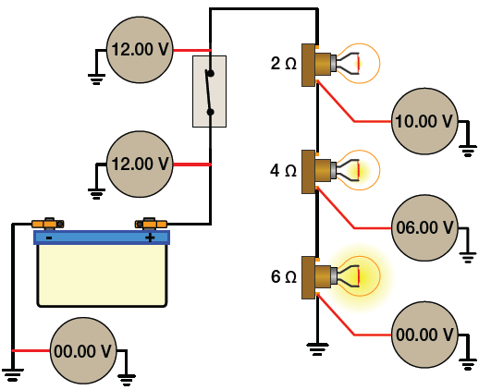
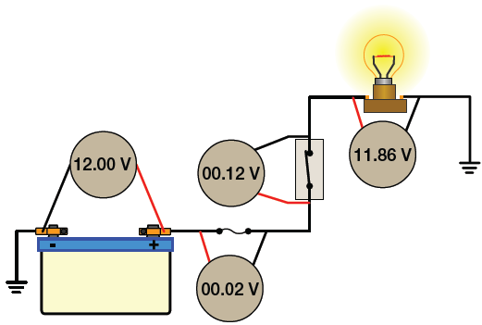 | 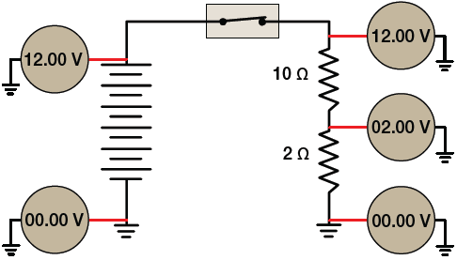
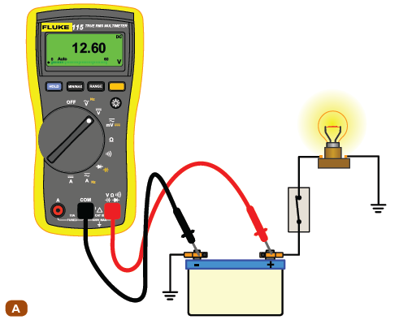Measuring Voltage of Battery | 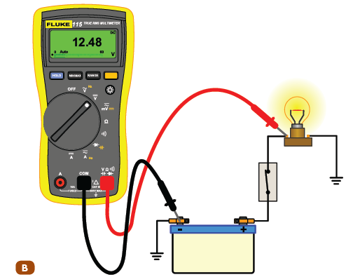Measuring (V) at input of Load
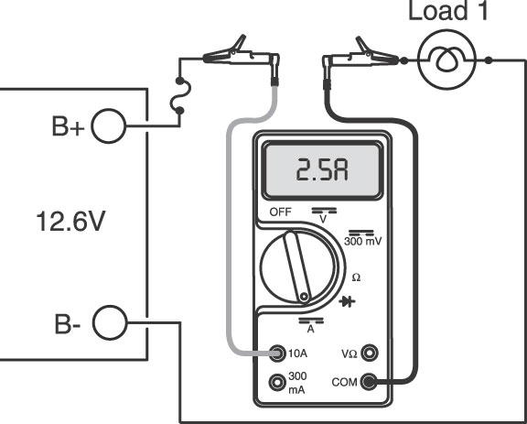 | 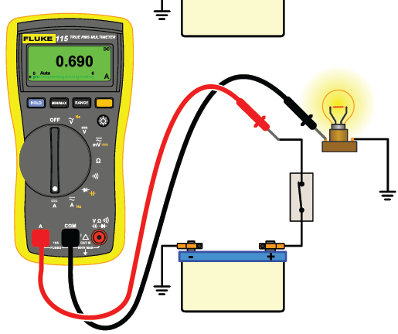
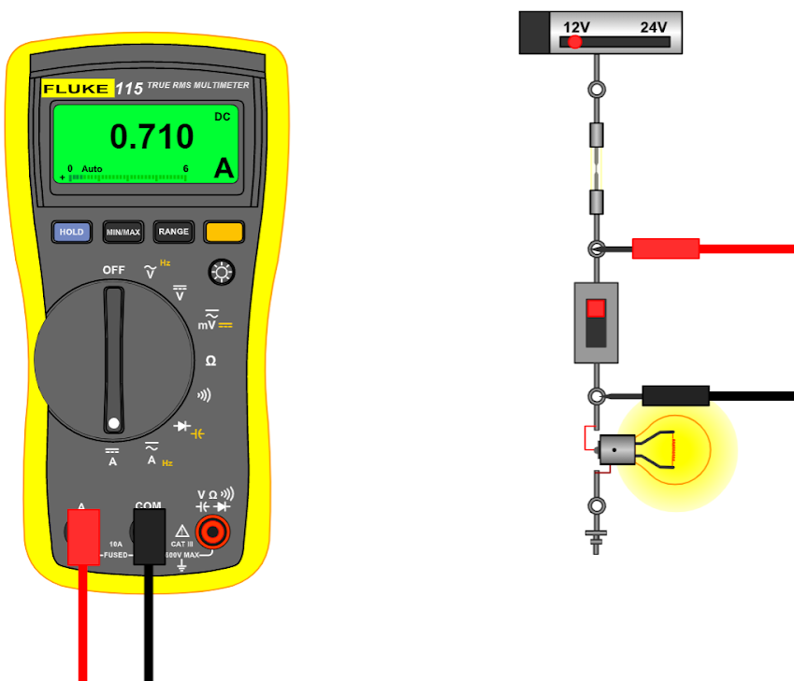 | 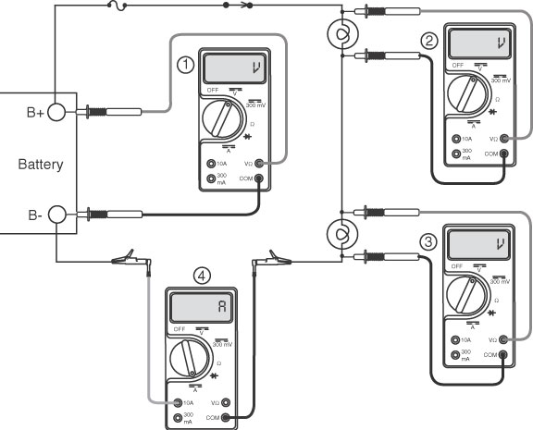

Converting Unit Ranges
1mV = ______________V  1 kV = ______________V  1 MV = ______________V | 1mΩ = ______________Ω  1 kΩ = ______________Ω  1 MΩ = ______________Ω | 1mA = ______________A  1 kA = ______________A  1 MA = ______________A | 1mW = ______________W  1 kW = ______________W  1 MW = ______________W

Section 4 | Electrical Diagnostics
Diagnose from evidence: verify the complaint, predict normal values, test strategically, and confirm the repair.

Six-Step Diagnostic Process
Step 1:

Step 2:

Step 3:

Step 4:

Step 5:

Step 6:

Circuit Malfunction Types:

Three Types of Customer Complaints
- No Operation: An Example: ___________________________________________________________________________
- Poor Operation: An Example: ___________________________________________________________________________
- Unwanted Operation: An Example: ___________________________________________________________________________

Define each root cause of an electrical fault and give an automotive example.
- Open Circuit

- Unwanted Resistance

- Shorted Circuit

- Intermittent Faults

- Hard Fault

Voltage Prediction

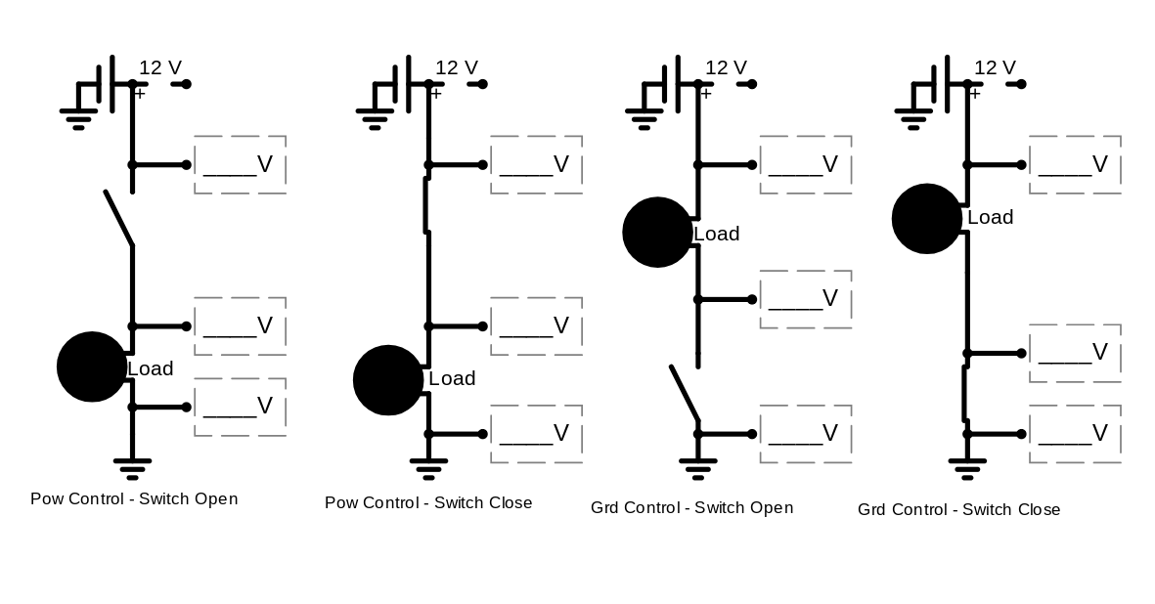
1. Available Voltage at input of Load | 6. Voltage Drop of Power Side
2. Available Voltage at output of Load | 7. Voltage Drop of Ground Side
3. Available Voltage at input of switch | 8. Voltage Drop of Switch
4. Available Voltage at output of switch | 9. Voltage Drop of all loads in a series circuit
5. Voltage Drop of Load

- There should be ___V after load with power control switch open  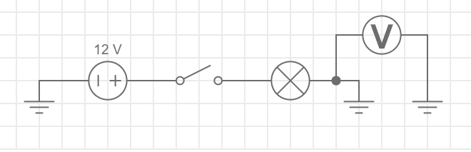 | - There should be ___V before load with power control switch open  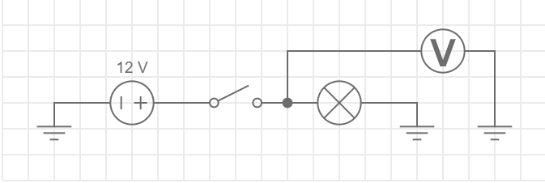
- There should be ___V after load with power control switch closed  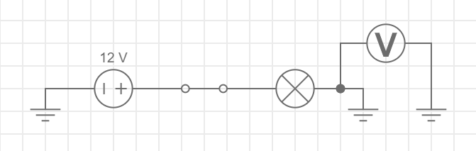 | - There should be ___V before load with power control switch closed  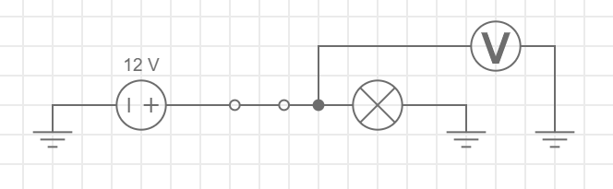
- There should be ___V after load with ground control switch open  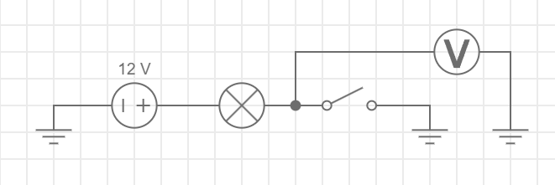 | - There should be ___V before load with ground control switch open  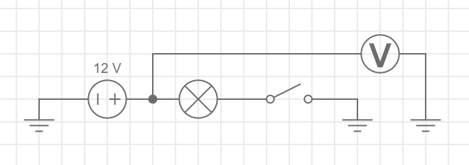
- There should be ___V after load with ground control switch closed  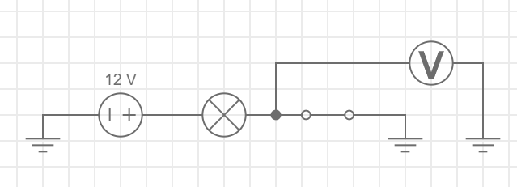 | - There should be ___V before load with ground control switch closed  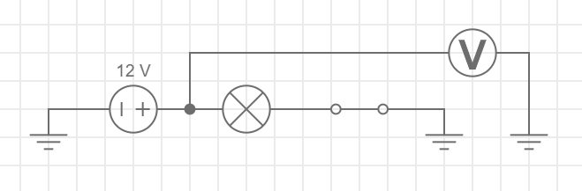

Check Your Predictions
Compare each reading with the circuit state and explain why the meter displays that value.
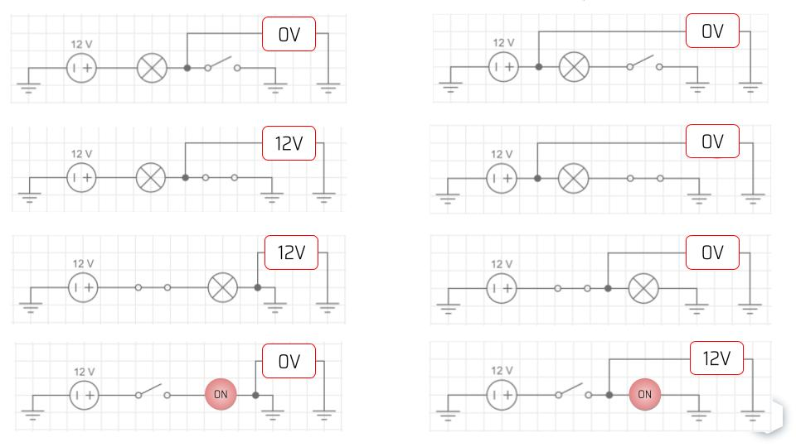

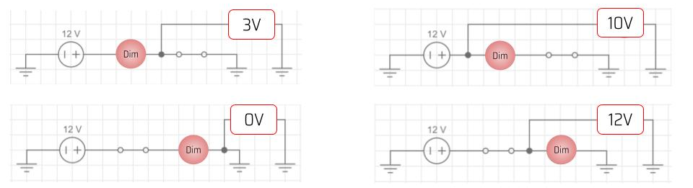

Available-Voltage Pattern Reference
Use the node pattern to connect circuit position, switch state, and expected voltage.
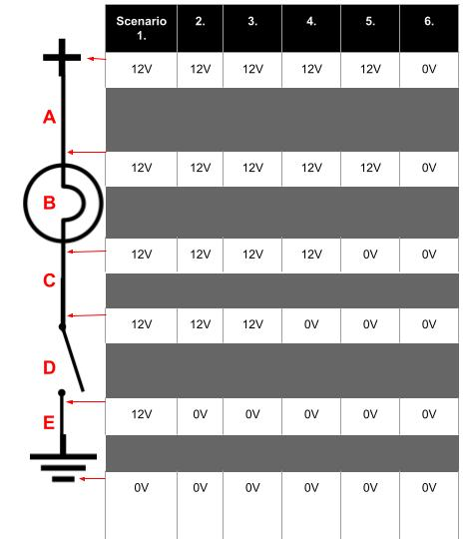

Section 5 | Ohm’s Law & Watt’s Law
Formula reference + calculation practice. Write the formula, substitute values, solve, and label the unit.

Quick Reference
OHM’S LAW | WATT’S LAW
E = I x R | P = E x I
I = E / R | P = I² x R
R = E / I | P = E² / R
Unit key: E = voltage (V) | I = current (A) | R = resistance (Ω) | P = power (W)

Circuit Rules
VALUE | SERIES CIRCUIT | PARALLEL CIRCUIT
Voltage | Individual drops add to source voltage | Same across every branch
Current | Same everywhere in the circuit | Branch currents add to total current
Resistance | Rt = R1 + R2 + … | 1/Rt = 1/R1 + 1/R2 + …
Power | Individual power values add to total | Individual power values add to total

Solve Every Problem This Way
- List the known values and the unknown value, including units.
- Choose a formula that contains the unknown and the known values.
- Substitute, solve, and carry the correct unit through the calculation.
- Perform a reasonableness check: does the answer fit the circuit behavior?

Calculation Practice
Use the four-step method. Show substitutions and label every final answer.
- A 12.6 V source is connected across a 4.2 Ω load. Calculate circuit current.

- A component carries 2.5 A and has 0.80 Ω of resistance. Calculate its voltage drop.

- A 12.0 V motor draws 3.0 A. Calculate electrical power.

- A 12.0 V series circuit contains 2 Ω, 4 Ω, and 6 Ω loads. Find Rt, It, and each voltage drop.

- Three parallel branches of 6 Ω, 12 Ω, and 4 Ω are connected to 12.0 V. Find each branch current, It, Rt, and total power.

Parallel Circuits

- Et _____  - It _____  - R1 _____  - R2 _____  - R3 _____  - IR1 _____ | - IR2 _____  - IR3 _____  - ER1 _____  - ER2 _____  - ER3 _____

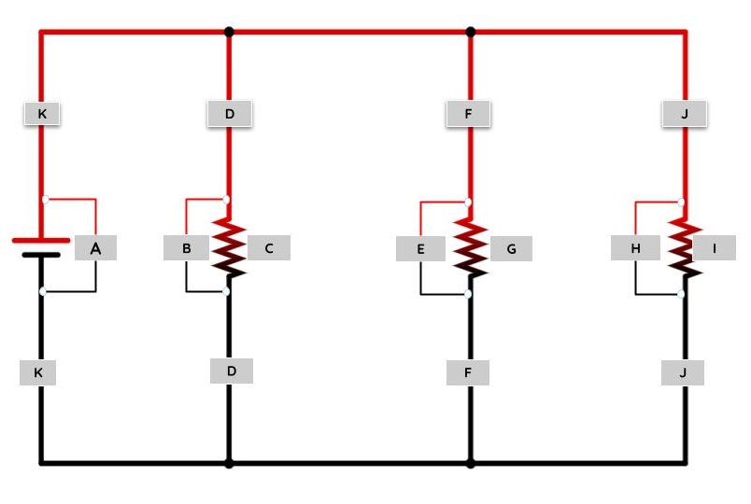

Section 6 | Essential Questions
Answer in complete, technically accurate sentences. Use an automotive example when it strengthens your explanation.
- What is electricity?

- Define voltage.

- What is current?

- What is the unit of resistance?

- How is an electron related to electricity?

- What are conductors and insulators? Can you provide an example of each?

- What is the difference between AC (Alternating Current) and DC (Direct Current)?

- What is a circuit?

- What does a switch do in an electrical circuit?

- What are the positive and negative battery terminals, and what does each represent?

- What is Ohm's Law?

- What is the purpose of a resistor?

- How does a light bulb work?

- What are the dangers of a short circuit?

- Why do we use fuses or circuit breakers?

- What is the function of a capacitor?

- What is the basic principle behind a transformer?

- What does a diode do?

- Why is grounding important in electrical circuits?

- What is the purpose of a transistor?

- Which meter modes measure voltage, current, and resistance, and how is each meter connected?

- Why are wires typically coated or insulated?

- What's the difference between series, parallel, and series-parallel circuits?

- What is electromagnetic induction?

- Why shouldn't you use electrical equipment near water?

- What does LED stand for and how does it differ from a traditional bulb?

- What is the role of a circuit-protection device in an automotive circuit?

- Why is measured amperage less than calculated amperage?

Readiness Reflection
The topic I can explain most confidently is:

The topic I need to review again is:

One specific question I will ask before the midterm is:

My study plan (day / time / resource) is:

